A Micro Project Report

on

Problem Solving using C Language

Submitted by

Boddu Ganesh Reddy(23471A05DF)



DEPARTMENT OF COMPUTER SCIENCE AND ENGINEERING

# NARASARAOPETA ENGINEERING COLLEGE: NARASARAOPET

(AUTONOMOUS)

Accredited by NAAC with A+ Grade and NBA under Tier-1

NIRF rank in the band of 201-300 and is an ISO 9001:2015 certified Approved by

AICTE, New Delhi, Permanently affiliated to JNTU Kakinada, Approved by AICTE,

Accredited by NBA and accredited ’A+’ grade by NAAC Narasaraopet-522601,

Palnadu(Dt.), Andhra Pradesh, India

2024-2025

NARASARAOPETA ENGINEERING COLLEGE:NARASARAOPET

(AUTONOMOUS)

## DEPARTMENTOF COMPUTERSCIENCEAND ENGINEERING



## CERTIFICATE

This is to certify that Boddu Ganesh Reddy, Roll No: 23471A05DF, a Second Year

Student of the Department of Computer Science and Engineering, has completed the Micro Project Satisfactorily in “Problem Solving using C Language" for the Academic Year 20242025..

|  |  |
| --- | --- |
| ProjectCo-Ordinator | HEAD OFTHE DEPARTMENT |
| Dr. Rama Krishna. Eluri, M.Tech.,Ph.D. | Dr. S. N. Tirumala Rao, M.Tech., Ph.D. |
| Asst. Professor | Professor |

# INDEX

|  |  |
| --- | --- |
| S.No | Description |
| 1. | C Program to Generate Equilateral Triangle Shape Pattern |
| 2. | C Program to Generate Hollow Diamond Pattern Using Stars |
| 3. | C program to given a string, consisting of alphabets and digits, find the frequency of each digit in the given string |
| 4. | C program given a sentence, print each word of the sentence in a new line. |
| 5. | Write a C program Attempt the following:  Twenty five numbers are entered from the keyword into an array. The number to be searched is entered through the keyword by the user. Write a program to find the number to be searched is present in the array and if it is present, display the number of times it appears in the array. |

**FREQUENCY COUNT OF DIGITS**

AIM:

**Write a C program to given a string, consisting of alphabets and digits, find the frequency of each digit in the given string.**

#include<stdio.h>

void main()

{

char str[100];

int freq[10]={0};

int i;

printf("enter a string:");

scanf("%s",str);

for(i=0;str[i]!='\0';i++)

{

if(str[i]>='0' && str[i]<='9')

{

freq[str[i]-'0']++;

}

}

printf("digit frequency in the given string:");

for(i=0;i<10;i++)

{

printf("frequency of %d:%d\n",i,freq[i]);

}

}

**input**

enter a string:ganrsg598723523622

**output**

digit frequency in the given string:frequency of 0:0

frequency of 1:0

frequency of 2:4

frequency of 3:2

frequency of 4:0

frequency of 5:2

frequency of 6:1

frequency of 7:1

frequency of 8:1

frequency of 9:1



AIM:

Write a C program to print an equilateral triangle shape pattern.

#include<stdio.h>

void main()

{

int n,i,j;

printf("enter the number of rows:");

scanf("%d",&n);

for(i=0;i<n;i++)

{

for(j=1;j<=n-i-1;j++)

{

printf(" ");

}

for(j=0;j<=i;j++)

{

printf("* ");

}

printf("\n");

}

}

**input**

enter the number of rows:5 **output**

**\***

**\* \***

**\* * \***

**\* * * \***

**\* * * * \***

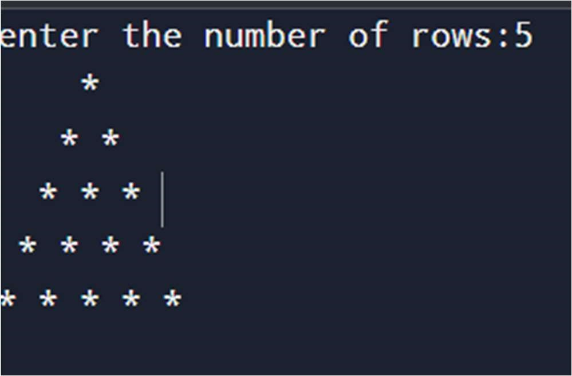



AIM:

C program to generate hollow diamond pattern using stars

#include<stdio.h>

void main()

{

int n,i,j;

printf(" enter the number of rows:");

scanf("%d",&n);

for(i=1;i<=n;i++)

{

for(j=n;j>i;j--)

{

printf(" ");

}

printf("* ");

for(j=1;j<(i-1)*2;j++)

{

printf(" ");

}

if(i==1)

{

printf("\n");

}

else

{

printf("*\n");

}

}

for(i=n-1;i>=1;i--)

{

for(j=n;j>i;j--)

{

printf(" ");

}

printf("* ");

for(j=1;j<(i-1)*2;j++)

{

printf(" ");

}

if(i==1)

{

printf("\n");

}

else

{

printf("*\n");

}

}

}

**Input**

enter the number of rows:3

**output**

**\***

**\* \***

**\* \***

**\* \***

**\***

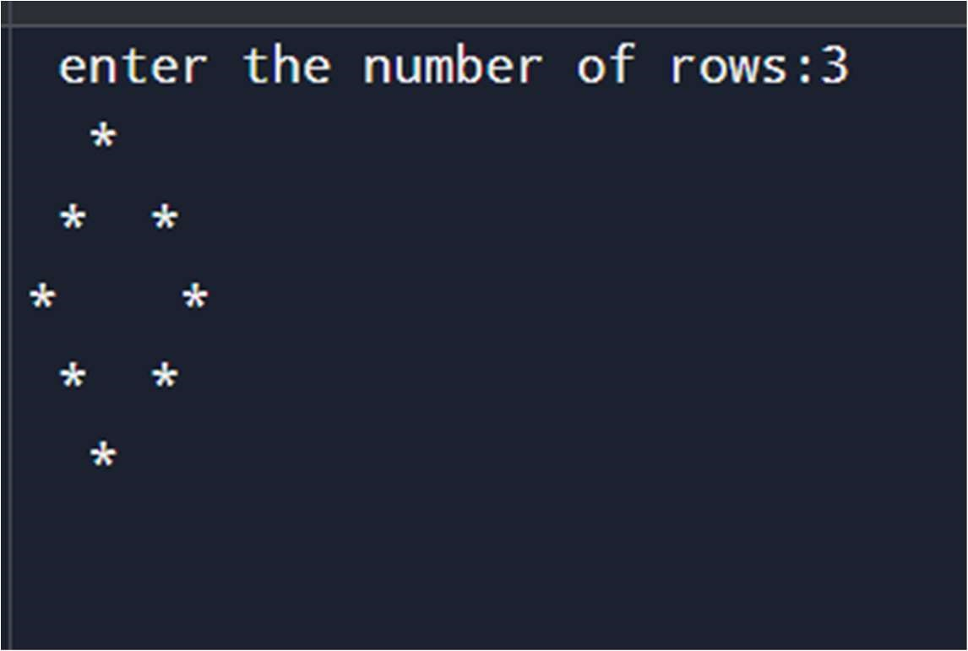



AIM:

C Program Given a sentence ,print each word of the sentence in a new line.

#include<stdio.h>

#include<string.h>

void main()

{

char str[1000];

printf("enter a sentence:");

scanf("%[^\n]%*c",str);

for(int i=0;str[i]!='\0';i++)

{

if(str[i]==' ')

{

printf("\n");

}

else

{

printf("%c",str[i]);

}

}

}

**input**

enter a sentence:i am ganesh reddy **output**

i

am

ganesh

reddy

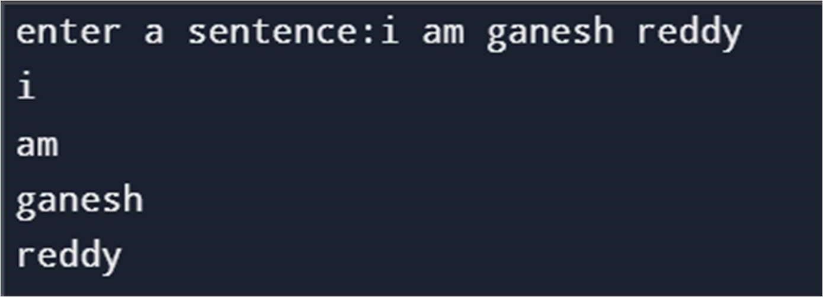



Twenty-five numbers are entered from the keyboard into an array. The number to be searched is entered through the keyboard by the user. Write a program to find if the number to be searched is present in the array and if it is present, display the number of times it appears in the array.

#include<stdio.h>

void main()

{

int arr[25];

int key,count=0;

printf(" enter the numbers:");

for(int i=0;i<25;i++)

{

scanf("%d",&arr[i]);

}

printf(" enter the element to search\n");

scanf("%d",&key);

for(int i=0;i<25;i++)

{

if(arr[i]==key)

{

count++;

}

}

if(count>0)

{

printf("%d appears %d times in array\n",key,count);

} else { printf("%d is not present in the array\n",key);

}

}

**input**

enter the numbers1 2 3 4 5 6 7 8 9 10 11 12 13 14 15 16 17 18 19 20 21 22 23 24

25

enter the element to search 22

**output**

22appears 1 times in array

